ENVIRONMENTAL, SOCIAL, HEALTH AND ECONOMIC RISKS OF OIL & GAS EXPLORATION IN MATATIELE
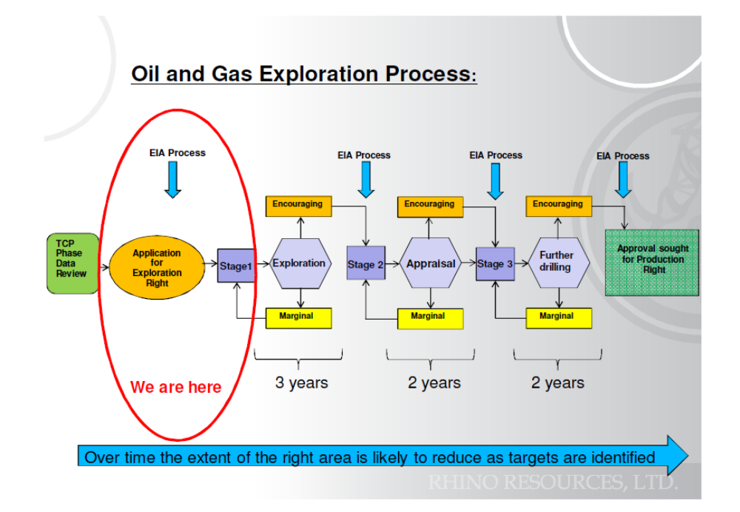

“Natural gas is a flammable gas, consisting largely of methane and other hydrocarbons, occurring naturally underground (often in association with petroleum) and used as fuel.”
Both conventional and unconventional gas are natural gas – the difference is in how they are extracted:
- Conventional gas (CG) is located in geological pockets or permeable rocks and can escape freely after drilling.
- Unconventional gas (UG) is trapped in impermeable rock formations, such as shale, tight sands and coal beds (also called coal seam gas in Australia), that need to be fractured in order to release gas in commercial quantities.
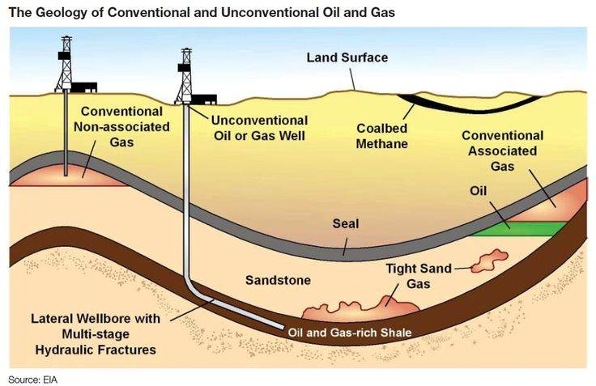
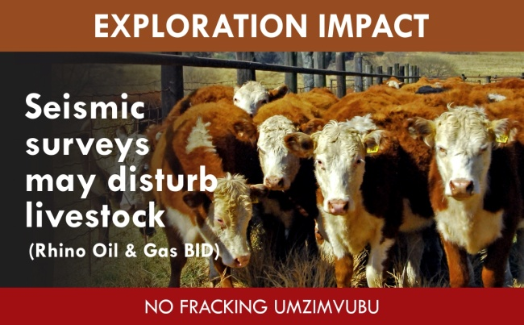
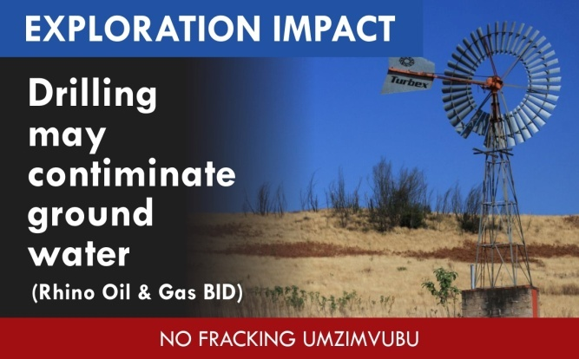
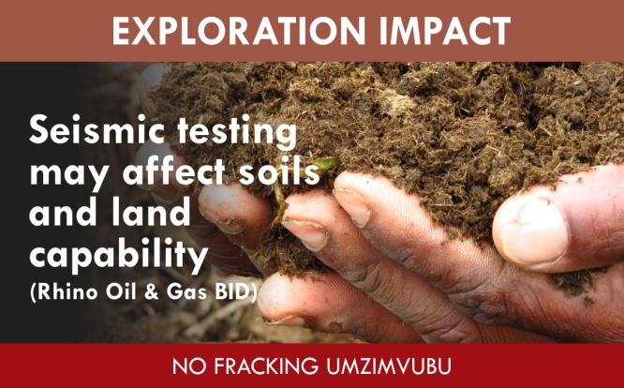

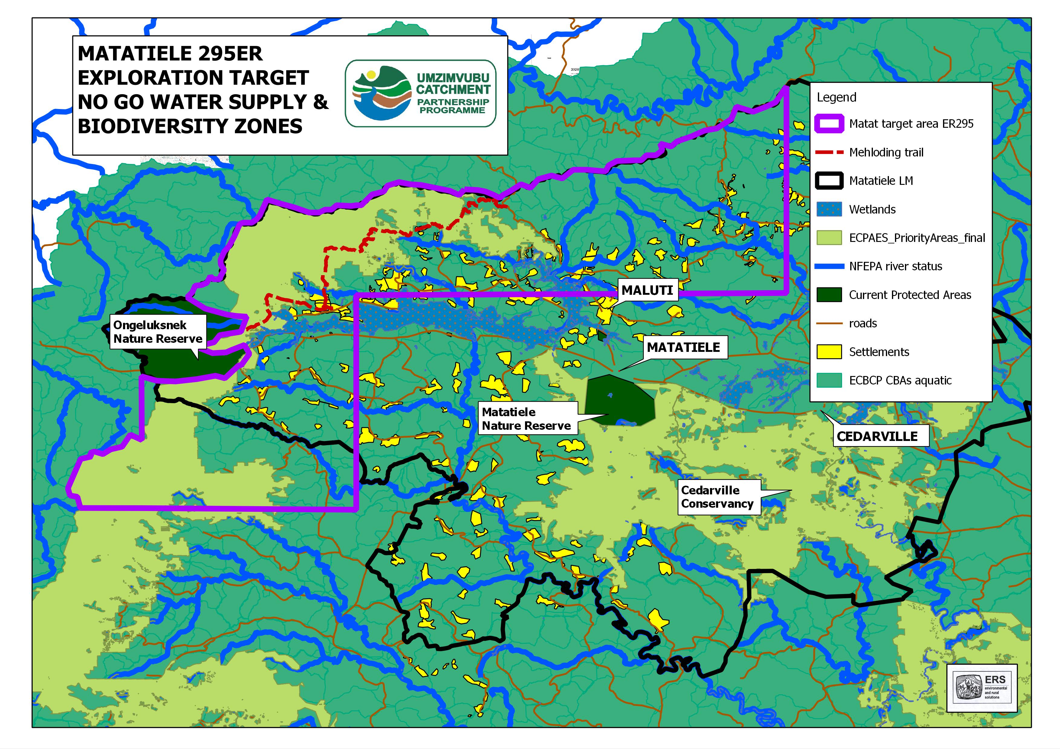
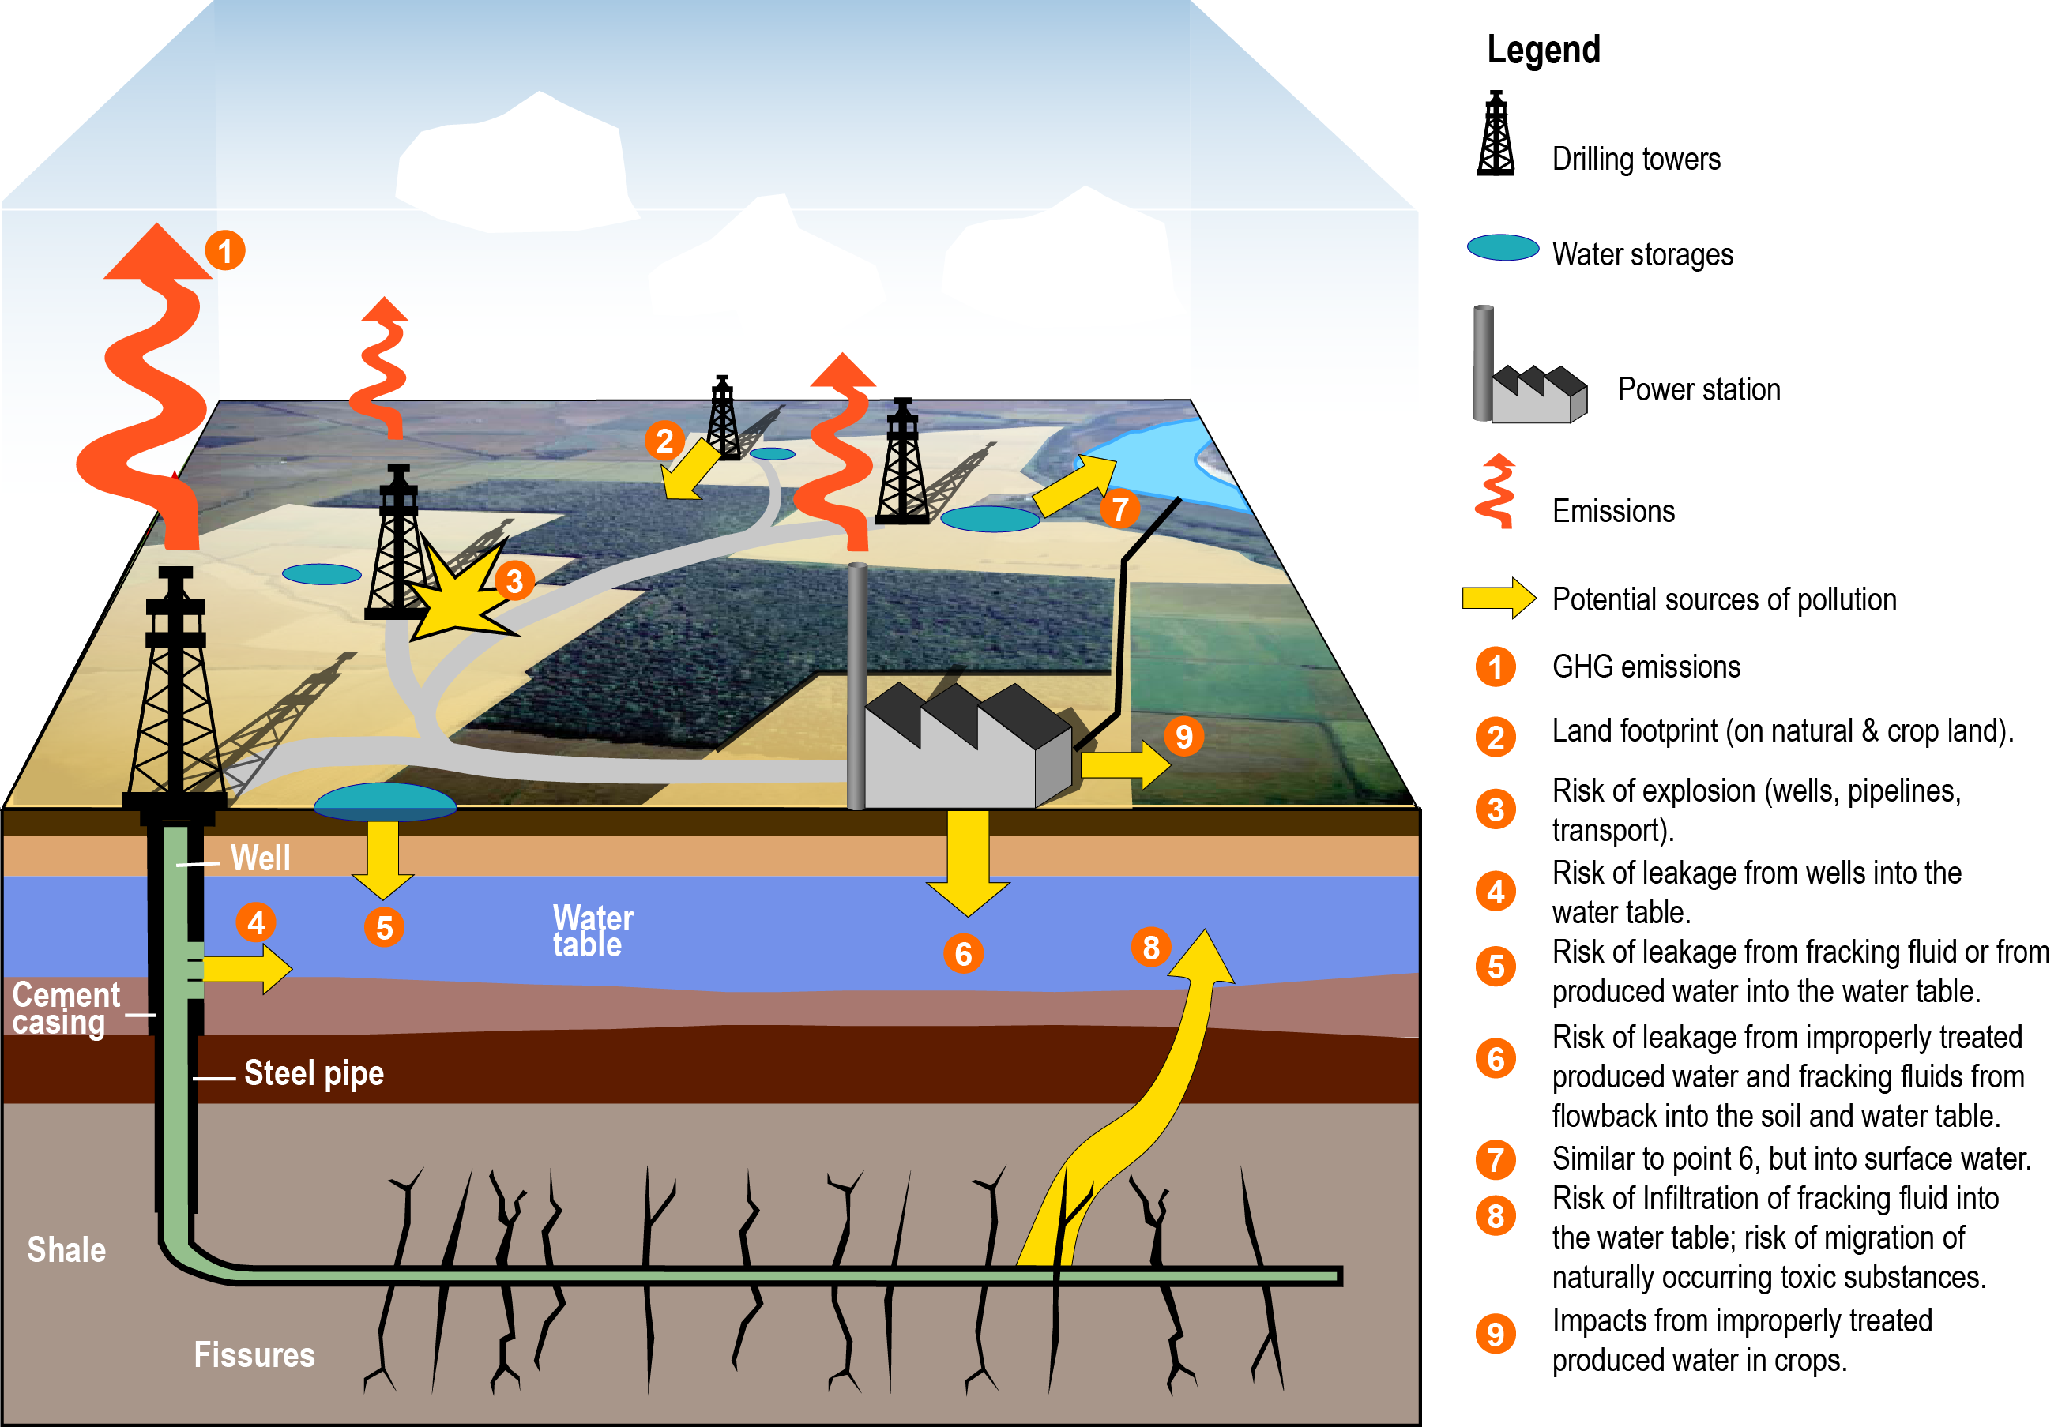

Main water issues associated with Unconventional Gas
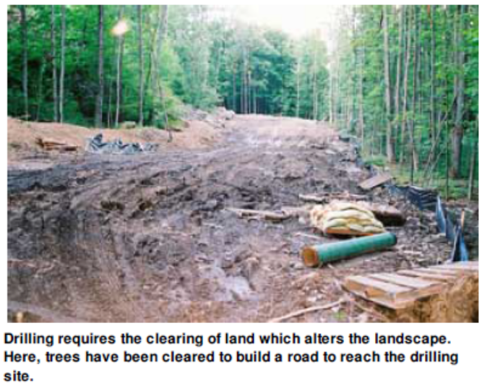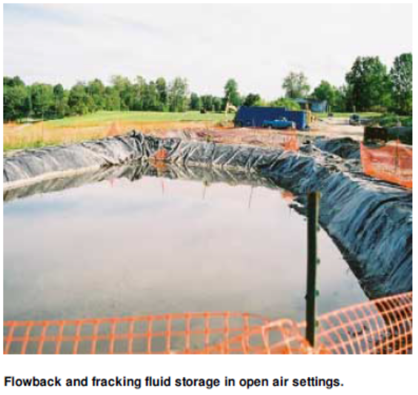

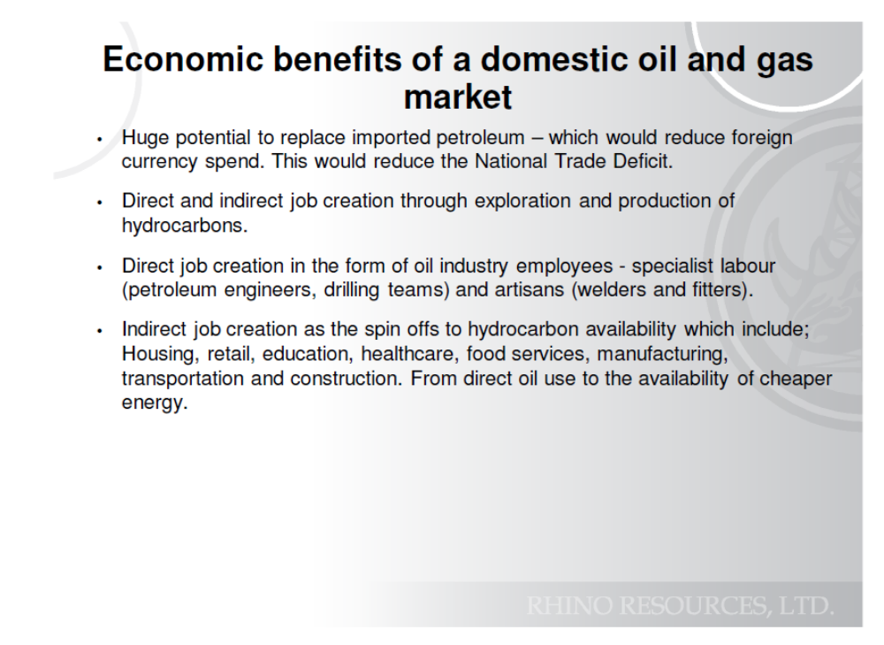
- Production of Unconventional Gas (UG) may result in unavoidable environmental impacts even if extracted properly, and more so if done inadequately. Even if risk can be reduced theoretically, in practise many accidents from leaky or malfunctioning equipment as well as from bad practises are regularly occurring.
- There is a serious lack of capacity to monitor and enforce compliance with any conditions of approval for the extraction and production.
- Long terms health risks (after production is finished) could include birth defects for humans and animals
- Air and water pollution are serious threats which we cannot control once started
- Ultimately, the solution is to reduce dependence on fossil fuels, and build on local agricultural production.

